ATAR Physics 11

Unit 1

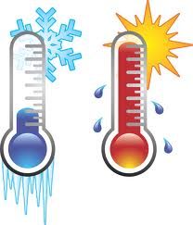

Heating Processes

The kinetic particle model describes matter as consisting of particles in constant motion, except at absolute zero.
Kinetic Theory of Matter

Assumptions of the Kinetic Theory
- All matter consists of tiny particles, namely atoms, molecules or ions.
- Electrical forces of attraction and repulsion exist between these particles.
- All these particles continually move or vibrate randomly, and hence they all possess kinetic energy. (Except at 0 K, -273 °C)
- Collisions between the particles involve no loss of kinetic energy, except when they lead to chemical reactions. That is, the particles are said to be perfectly elastic in their collisions.

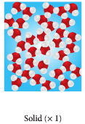
Solids, Liquids and Gases

SOLIDS
- strong attractive forces hold particles together
- repulsive forces stop collapse of matter
- held in fixed positions and vibrate
- shape difficult to change

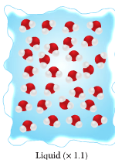
LIQUIDS
- weaker forces allow particles more freedom but still close together
- particles still close together so hard to compress
- flow to lowest part of container

GASES
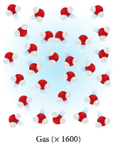
- particles move freely as little forces holding together
- take up shape of container
- volume same as volume of container
- forces only exerted during collisions
- low density compared to solids and liquids
- easy to compress as particles far apart

- In general, when heated, substances gain energy; initially kinetic as particles move faster, then as forces of attraction become weaker and particles move apart, they gain potential energy.

- This results in changes of state. The reverse occurs if substances are cooled.

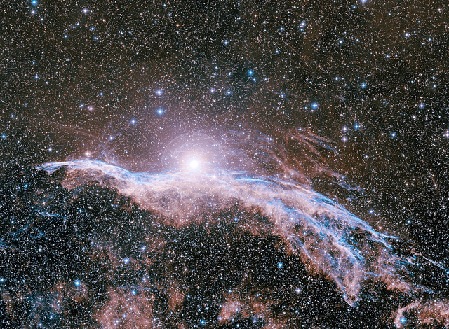
PLASMA
- The fourth state of matter, plasma is composed of rapidly moving charged particles.
- This makes up most of the matter in the universe.

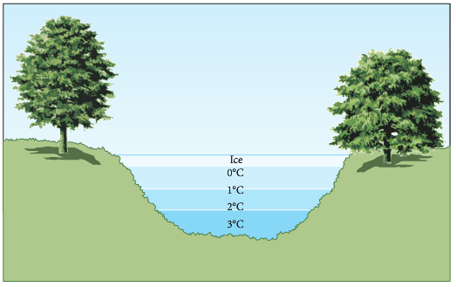
- Water is the only substance that expands when it freezes. As it cools, the particles come closer together until it reaches ~ 4 °C. After this, the water expands, becomes less dense and rises. Ice floats.

PP 1.1 p 4-5

All substances have internal energy due to the motion and separation of particles.

Kinetic Energy:
- Kinetic energy is the energy of movement. All moving objects have kinetic energy. Kinetic energy can be calculated: E_{k} = ½ mv².

Potential Energy
- Potential energy is stored energy due to position.
- Potential energy can be gravitational due to its position above a reference point and this can be calculated: E_{p} = mgh.
- Chemical potential energy due to stored energy within the molecules of substances.
- Nuclear potential energy held within atoms.
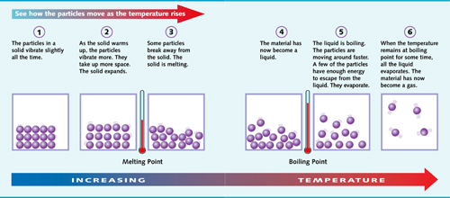

Thermal Energy (or Internal Energy)
- The thermal energy of an object is the total of the potential and kinetic energies of all the particles within the objects (this is sometimes known as the internal energy of the object).

- As the particles that make up the object are always moving (vibrating, rotating and/or translating) they have kinetic energy.

- They are also attracted or repelled by neighbouring particles so have a position in relation to other particles – this is their potential energy.

PP 1.1 p 6-7

Temperature is a measure of the average kinetic energy of particles in a system.
Heat
- Heat is the transfer of thermal energy from a hotter object to a cooler object due to a temperature difference.
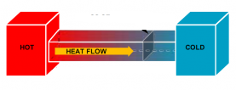
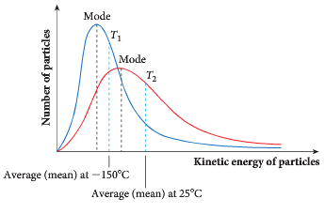
Temperature
- Temperature is a measure of the average kinetic energy of the particles in the object. We use a thermometer to give an exact measurement in degrees Celsius or in Kelvin.

- The temperature doesn’t depend on the potential energy but on the average kinetic energy.

- As a solid is heated, the particles move faster – their average kinetic energy increases and the temperature rises.

- If a phase change occurs, the temperature does not rise. Heat energy goes into increasing the potential energy of particles.

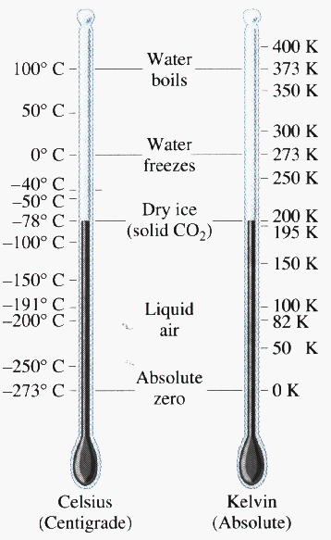
- It is possible to have ice at 0°C and water at 0°C. The average kinetic energy of the particles would be the same (same temperature) but the particles in the liquid phase have higher potential energy – the particles are a little further apart.

Measuring Temperature
- Thermometers are used to measure temperature. The liquid inside (usually mercury or alcohol) expands at a constant rate. A scale on the outside is calibrated, often between 0°C and 100°C.

- Absolute zero, -273.15°C or zero kelvin (0K) occurs when particles have no kinetic energy.

- An interval of 1K is the same as 1°C. The boiling point of water is usually 100°C or 373K.

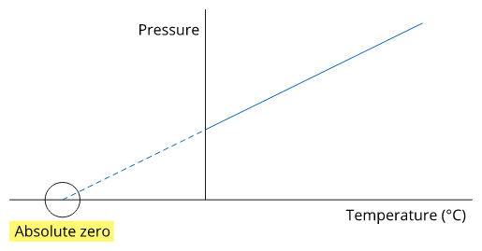
Graph of pressure versus temperature of a gas within a container of fixed volume.

- Some interesting temperatures
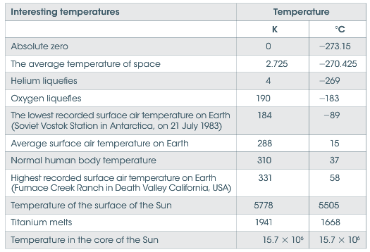

PP 1.1 p 7-8

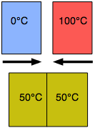
Thermal Equilibrium
- When two substances at different temperatures are mixed, heat will be transferred from the substance with the higher temperature to the one with the lower temperature.

- The amount of energy that the hotter object loses must equal the amount of energy that the colder object gains – conservation of energy.

- Thermal equilibrium is reached when two objects have the same temperature and heat transfer between the objects stops.

PP 1.1 p 8-9

- Summing it all up:
In your own words explain the difference between heat, temperature and thermal energy.

- Temperature Scales Answer p 32
- Heat is a transfer of energy so is measured in _______ symbol _____. Temperature, on the other hand, is measured using a __________ which is commonly in units called __________ __________.

- One degree Celsius is equal to one______ degree however the zero point on the Kelvin scale is at ________ zero or 0 K, this corresponds to _____ °C on a Celsius thermometer. Accurate thermometers are very expensive so the most commonly used one today is the liquid-in-glass type which has its fixed points as the __________ and __________ points of water e.g for a Celsius thermometer ____ and ________. The section in between is then divided into _____ equal divisions.

3. To convert Celsius to Kelvin, we simply add _______ K = °C + 273
To convert Kelvin to Celsius, we simply subtract ______ °C = K - 273.
4. Do the following:
- Convert these temperatures to Kelvin
- 25°C ______ c. 46°C ______
- – 200°C ______ d. 98°C ______
- Convert these temperatures to Celsius degrees
- 4 K ______ c. 50 K ______
- 200 K ______ d. 430 K ______
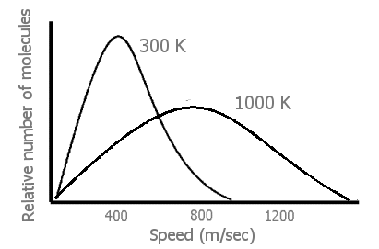
5. Explain what this graph is showing.

____________________________________________________
____________________________________________________
____________________________________________________

PP 1.1 Review p 10
WSG 1.1 p2-7 Q’s 1-9 p25
Provided a substance does not change state, its temperature change is proportional to the amount of energy added to or removed from the substance; the constant of proportionality describes the heat capacity of the substance.
Heat Capacity
Specific Heat Capacity
- When heat energy is gained or lost, there is a change in the kinetic energy of the body and therefore a change in its temperature.

- This change depends on:
- ______________________________ b. ____________________________________
- Change in temperature (ΔT) is dependent on the amount of heat added (Q), the mass of the material (m) and what the material is made of (specific heat – c).

- If Q then ΔT. If m then ΔT⬇. If c then ΔT⬇.

$$∆T= \frac{Q}{m c}$$

- To calculate specific heat: Q = mcΔT or mc(T₂ – T₁)

where: Q = heat gained or lost when temperature changes in joules (J)
m = mass of substance in kilograms (kg)
c = specific heat (Jkg⁻¹K⁻¹) and is unique for each substance
T = temperature in °C or K. NOTE: T₂ is always the higher temperature so there is never a negative answer.

- The Specific Heat Capacity (c) is the energy required to change the temperature of 1.0 kg of a substance 1.0 Kelvin and is a unique property of each material.

- Units of specific heat (c) are: Jkg⁻¹K⁻¹ (or Jkg⁻¹C⁻¹ as 1 degree Celsius is the same as 1 Kelvin).

- Different metals with the same mass, same initial temperature, placed on an ice block.

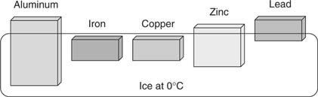
Al = 880 Fe = 450 Cu = 390 Zn = 390 Pb = 130

Answers p 32
- A 400 kg block of iron is heated from 22°C to 52°C . How much heat is absorbed by the iron? (Specific heat of iron is 450 Jkg⁻¹K⁻¹)

- 25.0 g of water at 90.0°C has 3657.5J of heat energy removed from it. What is its final temperature? (Specific heat of water is 4.18 x 10³ Jkg⁻¹K⁻¹)

- 50.0 g glass (specific heat of 670 Jkg⁻¹K⁻¹) at a temperature of 20°C has 4.0 x 10³ J of heat energy added. What is the final temperature of the glass?

- Questions:
- 43.0 g of Aluminium (c = 8.80 x 10² Jkg⁻¹K⁻¹) at 90.0°C is allowed to cool to room temperature (25.0⁰C), how much heat did the aluminium give off in the cooling process?

- 2.145 x 10³ J of heat is gained a mass of copper (c = 3.90 x 10² Jkg⁻¹K⁻¹) when it is heated from 63.0°C to 85.0°C . What was the mass of the copper?

- 3.50 x 10³ J of heat is added to 1.80 kg of lead (c = 1.30 x 10² Jkg⁻¹K⁻¹) which was initially at 10.0°C . What is the final temperature of the lead?

- 855 g of aluminium (c = 8.80 x 10² Jkg⁻¹K⁻¹) initially at 68.0°C was cooled by removing 2.69 x 10⁴ J of heat energy. What was the final temperature of the aluminium?

- An aluminium saucepan of mass 855 g has 0.200 kg of milk (specific heat 3.90 x 10³ J) in it which has been heated to a temperature of 90.0°C . How much heat energy must be removed for them both to reach a temperature of 45.0°C ?

PP 1.2 p 11-3 1.2 Review p 14
Change of state involves separating particles which exert attractive forces on each other; latent heat is the energy required to be added to or removed from a system to change the state of the system.
Change of State
- Substances may exist as solids, liquids or gases.
- If heat is applied to a substance then its temperature increases, that is, an increase in the average random kinetic energy of its particles.
- However, at particular temperatures, the applied heat causes a change of state.
- This change of state occurs without any change in temperature.
- The applied heat is absorbed by the particles as potential energy as they move further apart from each other.

Typical Heating Curve of a Pure Substance
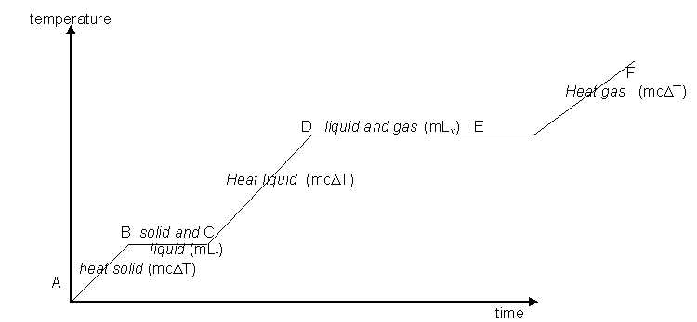
Latent Heat
- Latent heat is the heat that is absorbed or given off by a substance during a phase change.

- During this time there is no temperature change as the kinetic energy of the particles is not changed.
- All the energy is involved in changing forces of attraction (increasing E_{P}) between molecules so as to change the phase.

- Change from solid to liquid is called Latent Heat of ___________________________
- Change from liquid to gas is called Latent Heat of ___________________________

- Note that the Latent Heat of Fusion is less than the Latent Heat of Vaporization. This is always the case. Can you suggest why this is so?

______________________________________________________________________________
______________________________________________________________________________
______________________________________________________________________________

- The quantity of heat required to produce a change of phase is: Q = mL
where: Q = heat gained or lost during phase change in joules (J)
m = mass in kilograms (kg)
L = Latent Heat of Fusion (L_{f}) or Vaporization (L_{v}) in Jkg⁻¹.

PP 1.3 p 15-8
Answer p 33
- How much heat is required to evaporate 5.0 kg of benzene at its boiling point? The Latent Heat of Vaporization of benzene is 4.0 x 10⁴ Jkg⁻¹.

- Example showing how latent heat and specific heat can be combined
50 g of ice at –10°C is heated to steam at 120°C .

Complete the following example; you should get the answer – 1.53 x 10⁵ J

( c_{water} = 4.18 x 10³ J kg⁻¹ K⁻¹ , c_{ice} = 2.10 x 10³ J kg⁻¹ K⁻¹ , c_{steam} = 2.0 x 10³ J kg⁻¹ K⁻¹ )
( L_{f} = 3.34 x 10⁵ J kg⁻¹ , L_{v} = 2.25 x 10⁶ J kg⁻¹ )

Heat Energy = heat ice + ice to water + heat water + water to steam + heat steam
= mcΔT_{(ice)} + mL_{f} + mcΔT_{(water)} + mL_{v} + mcΔT_{(steam)}

- Heat Problems
specific heat of water = 4.18 x 10³ Jkg⁻¹K⁻¹ latent heat of vaporization water = 2.26 x 10⁶ Jkg⁻¹
specific heat of ice = 2.10 x 10³ Jkg⁻¹K⁻¹ latent heat of fusion water = 3.34 x 10⁵ Jkg⁻¹
specific heat of steam = 2.00 x 10³ Jkg⁻¹K⁻¹ specific heat of copper = 3.85 x 10² Jkg⁻¹K⁻¹
specific heat of steel = 4.50 x 10² Jkg⁻¹K⁻¹ specific heat of aluminium = 9.00 x 10² J kg⁻¹ K⁻¹
NOTE: Value for Aluminium is 9.00 x 10² J kg⁻¹ K⁻¹ in Exploring Physics.

- 0.1 kg of an unknown metal is found to require 3.5 kJ to change its temperature from 25°C to 82°C . What is the specific heat of the metal?

- The specific heat of copper is 3.85 x 10² J kg⁻¹ K⁻¹. A specific mass of copper has 1.74 x 10⁴ J of energy added to it to change its temperature from 20°C to 80°C. What was the mass of copper?

- If 15.7 kJ of heat energy is added to 250 mL of water at 20°C, what will the new temperature be?

- Over a period of 6 hours, a hot water bottle cools from 95°C to 20°C. If the hot water bottle held 2.5 L water, what is the rate of cooling in Js⁻¹?

- A kettle rated at 2000 W contains 1.8 L water at 15°C. If it runs for 3.5 minutes, will the water boil?

- How much heat energy is released when 423 g of steam at 100°C condenses to water also at 100°C?

- 4.87 x 10⁵ J of heat are added to a mass of ice at 0°C. If the ice melts and becomes water at 21.5°C , what was the mass of ice?

- At what rate in Js⁻¹ is a refrigerator absorbing heat from 2.15 kg of water at 21.5°C is just frozen in 2.00 hours?

PP 1.3 Review p 20
Two systems in contact transfer energy between particles so that eventually the systems reach the same temperature; that is, they are in thermal equilibrium. This may involove change of sate as well as change in temperature.
Thermal Equilibrium:
- If you place a hot piece of metal into a beaker of cold water, heat from the metal will transfer to the water.
- The temperature of the water will rise and that of the metal will fall until thermal equilibrium is reached (assuming no heat transfer to or from surroundings).

- In terms of kinetic theory we can say that the average kinetic energy of the atoms of metal has lowered and the average kinetic energy of the atoms of water has increased so that they are now both the same.
- In reaching equilibrium we should note that:
- Heat lost (by metal) = Heat gained (by water)
- The final average kinetic energy of the particles of both substances is the same.
Example:
30.0 mL of water at 90.0°C is added to 20.0 mL of water at 10.0°C in an insulated foam cup (assume no loss of heat to the cup or surroundings). What is the final temperature?

Heat lost = heat gained.
mcΔT_{(hot water)} = mcΔT_{(cold water)}
‘c’ same so can cancel, mΔT_{(hot water)} = mΔT_{(cold water)}
(0.0300 x [90.0 – T_{f} ] ) = (0.0200 x [T_{f} – 10 ] )
2.70 – 0.0300T_{f} = 0.0200T_{f} - 0.200
2.70 + 0.200 = 0.0300T_{f} + 0.0200T_{f}
2.90 = 0.0500T_{f}
T_{f} = 58.0°C
- Mini Experiment:
You are now to carry out a similar experiment yourselves. Collect two 50 mL measuring cylinders, two foam cup, two thermometers, two 100 mL beaker.
  - Add ice to about 50 mL of water in a beaker, stir until the water is around 10°C and pour 20 mL of this water into a foam cup.
  - Collect boiled water from the kettle in a beaker, return to desk and measure out 30 mL into a foam cup. Measure the temperature and record below.
  - Re-check the temperature of the cold water and add it to the 30 mL hot water in the foam cup.
  - Stir well and record the final temperature then calculate the expected final temperature.

Results: Calculation of expected temperature
Temperature of cold water _________ heat lost = heat gained
Temperature of hot water __________ mcΔT _{(hot water)} = mcΔT _{(cold water)}
Temperature of mixture ____________

How did the actual temperature of the mixture and the expected temperature of the mixture compare? _____________________________________________________________________
Can you account for any differences? _______________________________________________
______________________________________________________________________________
______________________________________________________________________________

Method of Mixtures
- If two bodies at different temperature are placed in close contact, heat will flow from the hotter body until equilibrium is reached.

HEAT LOST FROM HOTTER BODY = HEAT GAINED BY COOLER BODY

- We know that the heat energy gained or lost, Q, is equal to mcΔT (or mc(T₂ – T₁) ), so
Q₁ = Q₂
or m₁c₁ΔT₁ = m₂c₂ΔT₂
- Method of mixtures deals with heat lost and heat gain where one of the substances changes phase (latent heat) as well as temperature (specific heat).

Example:
0.25 kg of ice at –30°C is added to 6.0 L of water at 70°C, assuming no loss of heat to the surroundings, what is the final temperature of the water?

Heat lost = heat gained
(warm water) = (heat ice) + (phase change ice) + (heat ice water)
(mcΔT_{water}) = (mcΔT_{ice}) + (mL_{f}) + (mcΔT_{ice water})
6.0 x 4.18 x 10³ x (70 – T_{f}) = (0.25 x 2.1 x 10³ x 30) + (0.25 x 3.34 x 10⁵) + (0.25 x 4.18 x 10⁵ x T_{f})
1755600 - 25080T_{f} = 15750 + 83500 + 1045T_{f}
1755600 – 15750 – 83500 = 25080T_{f} + 1045T_{f}
1656350 = 26125T_{f}
T_{f} = 1656350
26125
T_{f} = 63.4°C

- Heat Problems Answers p 35
specific heat of water = 4.18 x 10³ Jkg⁻¹K⁻¹ latent heat of vaporization water = 2.26 x 10⁶ Jkg⁻¹
specific heat of ice = 2.10 x 10³ Jkg⁻¹K⁻¹ latent heat of fusion water = 3.34 x 10⁵ Jkg⁻¹
specific heat of steam = 2.00 x 10³ Jkg⁻¹K⁻¹ specific heat of copper = 3.85 x 10² Jkg⁻¹K⁻¹
specific heat of steel = 4.50 x 10² Jkg⁻¹K⁻¹ specific heat of aluminium = 9.00 x 10² J kg⁻¹ K⁻¹
NOTE: Value for Aluminium is 9.00 x 10² J kg⁻¹ K⁻¹ in Exploring Physics.

- 20 g of milk at 5.00°C is added to 250 g of coffee at 90.0°C. What is the final temperature of the drink?

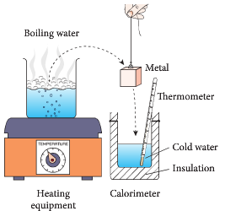
- 100 g of a metal at 95.0°C is added to 5.00 x 10² mL of water at 2.00°C. If the final temperature of the water is 3.60°C, what is the specific heat of the metal?

- How much heat energy is needed to change 1.00 kg of ice at –3.00°C to steam at 107°C?

- How much ice at 0.0°C must be added to 250 mL of coffee (specific heat: 4.10 x 10³ Jkg⁻¹K⁻¹) in an insulated cup (assume no loss of heat to the container and surroundings) to cool the coffee from 95°C to 65°C?

- Copper calorimeters are used to determine the specific heat of unknown substances. A calorimeter of mass 41 g, has 100 mL of water at 15°C placed in it. 50 g of iron is heated to 160°C then carefully lowered into the water. What would be the final temperature of the water? (specific heat of copper is 385 Jkg⁻¹K⁻¹ , iron is 477 Jkg⁻¹K⁻¹)

- 5.00 g of ice at –2.00°C is placed into a 78.0 g copper calorimeter containing 120 mL of water at 90.0°C. The water is stirred until all the ice has dissolved. What is the final temperature of the water?

- A 5.45 kg steel container contains 12.0 kg of water at 22.0°C. When 2.65 kg of molten alloy (latent heat of fusion 2.50 x 10⁴ J kg⁻¹ K⁻¹) at its melting point of 327°C is poured into the water the final temperature reached is 27.8°C. Find the specific heat of the alloy.

- How much ice at -4.00°C must be added to an aluminium calorimeter of mass 47.0 g containing 150 g of water at 95.0°C so that the final temperature once the ice has fully melted is 70°C?

PP 1.4 p 21-3 1.4 Review p 24
Chapter review p 25-6

WSG 1.2 p8-14 Q’s 10-23 p25-7

Heating and Cooling in the Human Body
Evaporation – a cooling effect:
Evaporation is an important effect of latent heat. Briefly, evaporation works by:
1. Water accumulates on skin from sweat glands (sweat).
- In suitable conditions, sweat evaporates.
- Evaporation is a change of phase and requires energy (latent heat)
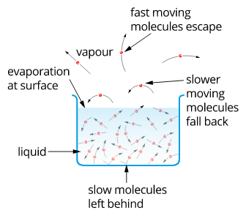
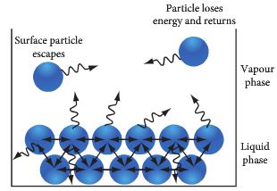

- Energy is taken from body so body feels cooler.

Controlling Body Temperature:

Cold – How we keep warm

Three main physiological ways:
1. Constricting blood vessels – limited effect – obvious by change in skin tone
2. Shivering – movement of muscles to generate internal heat – effective.
3. Chemical – use of such chemicals as adrenaline and
thyroxin to increase the metabolic rate.

Also behavioural ways:

- Clothing we wear
- Shelter
- Use of heaters
- Moving e.g. stamping feet

Heat – How we keep cool

Two main physiological ways:
- Evaporation (perspiration) – change of phase from liquid to gas requires large amount of energy (Q = mL), this energy is taken from the body and causes body to cool.
- Increase blood flow near surface of skin – limited effect.

Also behavioural

- Loose, light clothing
- Fans and air conditioners

- Minimal movement.

- Shelter.

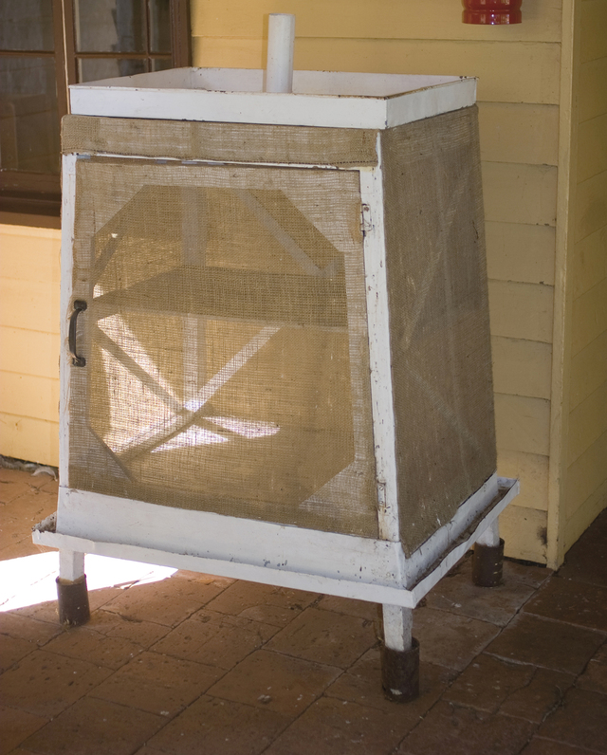
- The Coolgardie meat - a simple cupboard made of wire mesh and a wooden frame or pressed metal.
- A water tray was placed on top of the cupboard and the top of a hessian bag was attached to the water tray to soak up water.
- The wet hessian bag hung down, covering the safe like a flap.
- The Coolgardie meat safe was usually placed on a veranda or similar place where there was a breeze.
- The breeze passed through the wet hessian and the water evaporated.
- The energy required for evaporation to occur (latent heat) was drawn from the passing breeze or from the metal and hence the air or metal was cooled.
- This would cool the safe and thus the food inside it.

PP 1.3 p 19

A system with thermal energy has the capacity to do mechanical work [to apply a force over a distance]; when work is done, the internal energy of a system changes.
Work, heat and energy
- Heat is one way that energy can be transferred from one object to another.

- Another way is by work being done.
- When a force, F, acts on an object and moves it a distance, s, (in the same direction as the force), the energy transferred to the object is equal to the work done.

W = F s (W in joules (J), F in newtons (N), s in metres (m))
- Work = energy transferred by the action of a force.
- Heat = energy transferred due to temperature difference.

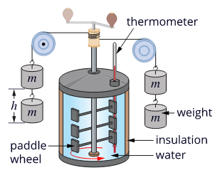
- Joule's apparatus for investigating the heating effect of mechanical work allowed the transfer of heat energy to be measured and related to other forms of energy.
- As the weights fall, there is a loss of potential energy. W = mgh
- The falling weights are connected to strings that cause the paddle wheel to spin – heating the water.
- In a closed system, the potential energy is equal to the thermal energy.
- The rate of energy transfer is called power. Power, P, is the energy, E, transferred per unit time.

$P= \frac{E}{t}$ (P in watts (W), E in joules (J), time in seconds (s))

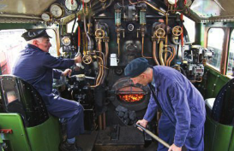
PP 2.1 p 28-30 2.1 Review p 31

Heat engine

- A heat engine is a system that converts heat or thermal energy to mechanical energy, which can then be used to do mechanical work.

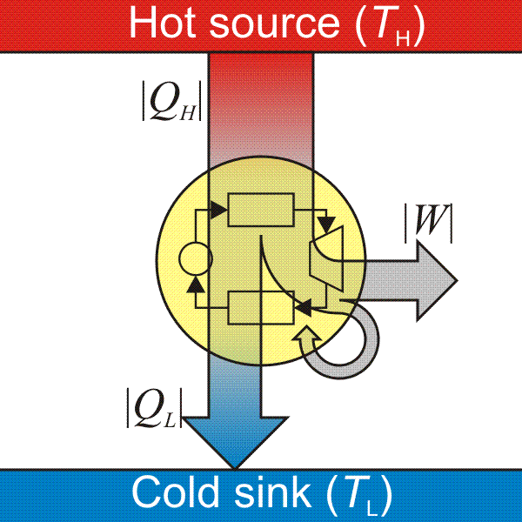
- It does this by bringing a substance (e.g. water) from a higher state temperature to a lower state temperature. T_{H} T_{L}

- A heat "source" generates thermal energy that brings the substance to the high temperature state.

- The substance generates work in the "body" of the engine while transferring heat to the colder "sink" until it reaches a low temperature state.

- During this process some of the thermal energy is converted into work. Q_{H} - Q_{L} = W
Because energy is conserved, the change in internal energy of a system is equal to the energy added by heating, or removed by cooling, plus the work done on or by the system.

- Consider the steam engine of a train as a system.
- Coal (or fuel) is burnt outside the engine.
- Energy enters the system as heat, Q_{in}, due to a difference in temperature.
- This heat boils water, creates steam and creates a force to move the train. Work, W, is done on the train.
- Some heat, Q_{out}, is lost to the environment.
- The energy transferred ΔE = Q_{in} – Q_{out} – W.
Heat source at T_{in}.
Heat source at T_{out}.

Heat engine
Energy (Q_{in}) enters the engine.
Energy (Q_{out}) leaves the engine.
Q_{in}
Q_{out}
W_{eng}
Work (W_{eng}) is done by the engine.

- A refrigerator is a heat pump that cools the inside section.
- Work is done by an electric motor to remove heat from inside the refrigerator.
- The electric motor compresses a refrigerant gas, causing it to rise in temperature.
- The refrigerant is passed to the outside, where it loses energy to the cooler surroundings.
- The liquid refrigerant is made to vapourise, causing it to cool.
- It now passes through the inside of the refrigerator where it extracts heat.
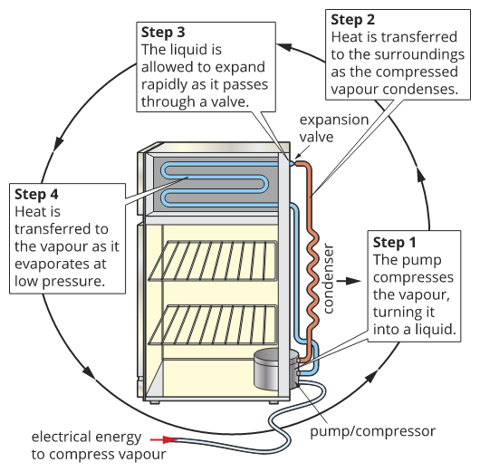
Phase change
vapour liquid

releases heat

Q = mL
Volatile liquid

liquid vapour

phase change requires heat

Q = mL
Warmer area at T_{out}.
Cooler area at T_{in}.

Heat pump
Energy (Q_{out}) is expelled to the warmer area.

Energy (Q_{in}) is drawn from the cooler area.
Q_{in}
Q_{in}
W
Work (W) is done on the heat pump.

- A refrigerator as a heat pump to remove energy from inside the refrigerator

PP 1.1 p 9

Heat transfer occurs between and within systems by conduction, convection and/or radiation.

Heat Transfer
- There are three main ways in which heat is transferred; these are conduction, convection and radiation.
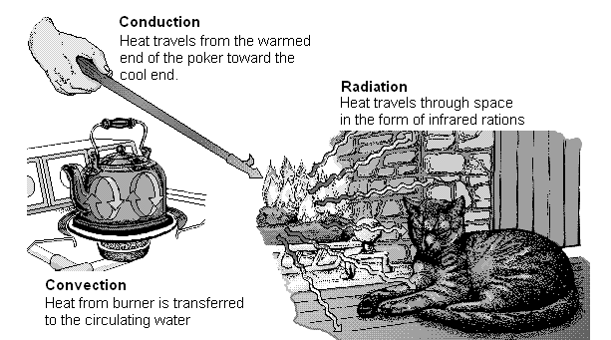
Conduction:
- Conductors are materials that easily allow heat to be transferred along them e.g. objects made of metal.
- Insulators are materials that do not conduct heat. Examples of insulators are glass, water, plastic, air, and materials with air trapped in them such as wool.

- Conduction of heat will only occur in solid objects as the heat is transferred along the particles that make up the solid.
- If we heat one end of a metal bar, the particles at that end increase their vibrations.
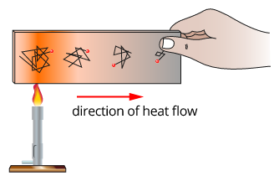
- Thermal energy is passed on by collisions between adjacent particles.
- This increase is passed rapidly along the bar from particle to particle until all particles are vibrating faster.
- This increase in movement is an increase in the average kinetic energy of the particles and therefore an increase in the temperature of the metal bar.

- When you pick up a cold piece of metal such as iron it feels cold. This is because the heat flows rapidly from your hands to the metal.

- The Kinetic Theory helps explain conduction:
- Particles in fixed position vibrate
- Increasing heat means particles vibrate faster and hit neighbouring particles harder.
- These in turn hit their neighbouring particles harder, so heat travels down solid.
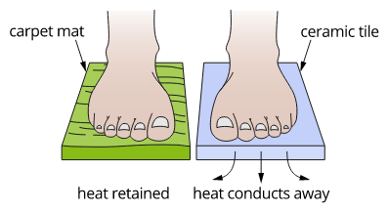
- Ceramic floor tiles conduct heat away from the foot readily and so will feel cold.
- The carpet mat is a thermal insulator so thermal energy from the foot is not lost as quickly and the foot doesn't feel as cold.

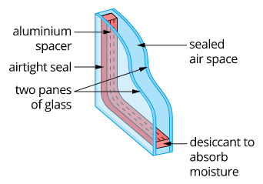

- Double-glazing window construction reduces heat loss through windows.

PP 2.2 p 32-4
2.2 Review p 35

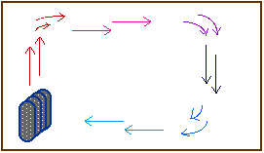
Convection:

- Convection can’t occur in solids but will occur in liquids and gases as convection is the mass movement of millions of particles.

- When a mass of air is heated it becomes less dense and therefore expands.
- Being less dense, the air floats upwards carrying the heat with it and the cooler air around it moves in to take its place.
- This cold air is then heated and it rises while the previously hotter air has cooled, becomes denser and therefore sinking back down.
- This moving of currents of warm and cold air is called convection currents and is used to heat a room as shown in the diagram.
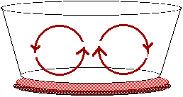

- Water will behave in exactly the same way.
- As the hotter part of the liquid expands and becomes less dense it rises upwards.
- Again, heat is carried upwards by the less dense liquid.
- Hot water systems use convection currents to keep the water hot.
- The diagram above shows convection currents in a pan of water on a stove speed up the heating of the entire pan of water.

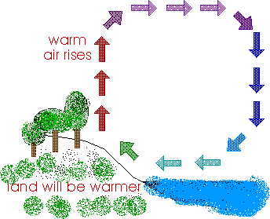
- Sea currents are also an example of convection currents.

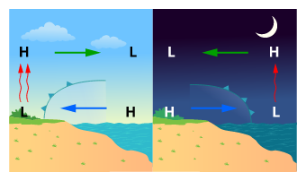
- Most of our ordinary weather is the result of convection. The warmer land causes the air to rise, cooler air moves in (see breeze).

- Land sea breezes are created by convection currents caused by the temperature difference between air over the sea and air over the land.

PP 2.3 p 36-7 2.3 Review p 38

Radiation
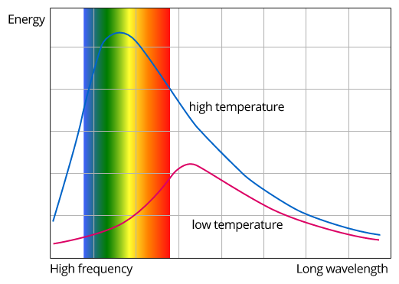
- Radiation is different from conduction and convection in that it is made of electromagnetic waves.

- A system at a low temperature will emit small amounts of radiation, which are of longer wavelengths.
- As the temperature of the system increases, more short-wavelength radiation is emitted and the total radiant energy emitted increases.

- These waves are made of infrared, light and ultra-violet rays and they warm up anything that absorbs them as they increase the average kinetic energy of the particles they hit.

- We are most familiar with radiation from the sun and from heaters.

- Different surfaces absorb heat in different ways.
- Shiny objects reflect heat so stay cooler, dull object absorb more heat.
- White colours reflects more heat so stays cooler, while black absorbs heat so get hotter. An object that is black with a dull surface absorbs the most heat.

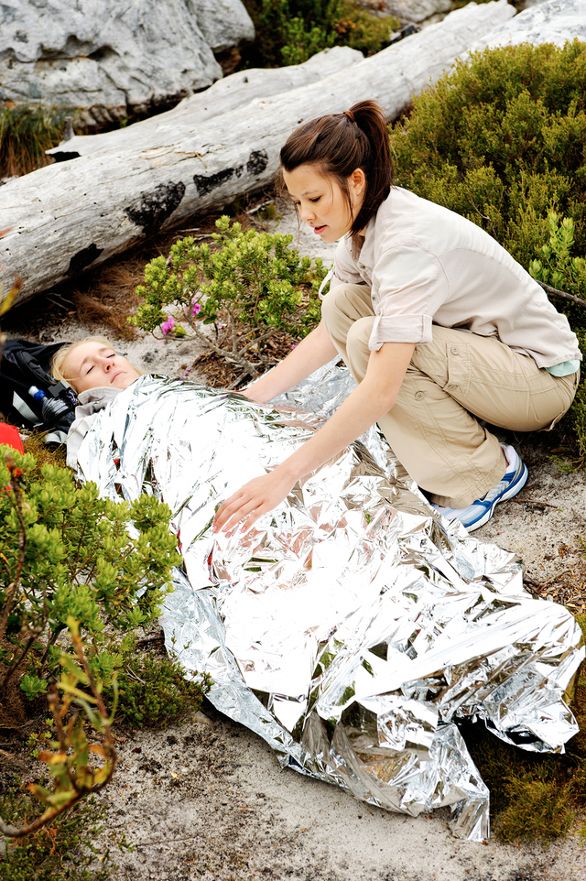
- The silvered surface of an emergency blanket reflects thermal energy back to the body, and retains the radiant energy, which would normally be lost by the human body.
- This simple method works as excellent thermal insulation.
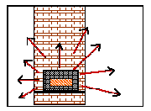
- The heater in the diagram shows radiation being given off to heat the room.

A Vacuum Flask – restricting heat transfer.
- A vacuum flask can keep liquids hot or cold for many hours by limiting the heat transfer process.
- The three forms of heat transfer involved are conduction, convection and radiation.
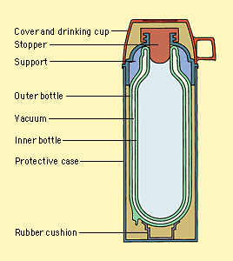
- As the diagram shows, a vacuum flask has two inner containers which are often made of glass with a vacuum in between the two layers.
- The glass is a poor conductor.
- The vacuum between the two layers reduces the heat transfer by convection.
- The surfaces of the inner layer are covered with silver to act like a mirror and reflect much of the heat coming from inside or outside so preventing heat transfer by radiation.

- Other features of vacuum flasks help minimize both the loss or entry of heat.
- Most vacuum flasks have a small mouth, which reduces heat exchange.
- The flasks are closed with a stopper made of cork, plastic, or some other material that conducts heat poorly.
- The inner container of a vacuum flask is encased in metal or plastic.
- A rubber collar around the mouth holds the inner container in place, and a rubber cushion at the base serves as a shock absorber.

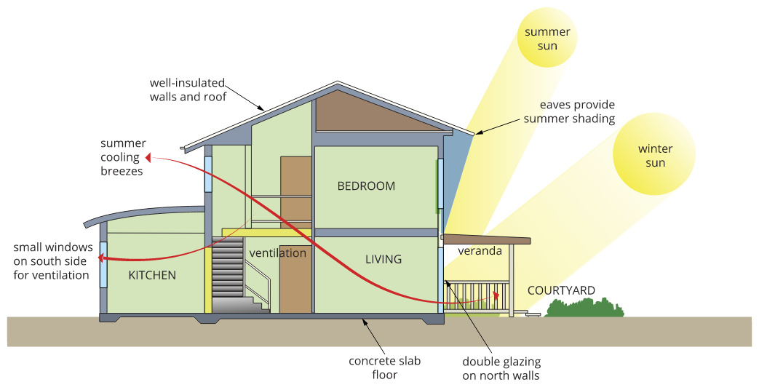
- Aspects of good passive solar design applied to housing design can lead to significant energy savings.

PP 2.4 p 39-41 2.4 Review p 42
Chapter review p 43-4
WSG 1.3 p15-8 Q’s 24-35 p27
STAWA Set 2

Heat Transfer Question: ANSWERS p28
- Explain the difference between a conductor and an insulator.

______________________________________________________________________________
______________________________________________________________________________
______________________________________________________________________________
- In what phase or phases of matter does conduction occur? _____________________________
- Explain what conduction is. ___________________________________________________
- How does conduction occur? Include a diagram.

______________________________________________________________________________
______________________________________________________________________________
______________________________________________________________________________
______________________________________________________________________________

- Some materials are good conductors and some poor. Explain what a material needs to be a good conductor. __________________________________________________________________
___________________________________________________________________________
- What materials are good conductors? _____________________________________
- Explain why if you stand with one foot on a carpet and one on a concrete floor, your feet feel as if they are at different temperatures. Does this mean that the two materials were at different temperatures?

______________________________________________________________________________
______________________________________________________________________________
______________________________________________________________________________
- What is convection?
______________________________________________________________________________
- In what phase or phases of matter does convection occur? __________________________
- Explain how convection occurs including a diagram.
______________________________________________________________________________
______________________________________________________________________________
______________________________________________________________________________
______________________________________________________________________________
______________________________________________________________________________

- What is radiation? _________________________________________________________
- Explain how radiation occurs including a diagram.
______________________________________________________________________________
______________________________________________________________________________
- Good insulating materials such as carpet, polystyrene and foam all contain trapped air. What are the advantages of this feature?
______________________________________________________________________________
______________________________________________________________________________
______________________________________________________________________________
______________________________________________________________________________
- Explain why birds fluff up their feathers on a cold day and have them flat on a hot day.
______________________________________________________________________________
______________________________________________________________________________
______________________________________________________________________________

- Summarize how a thermos flask minimizes all forms of heat transfer.
______________________________________________________________________________
______________________________________________________________________________
______________________________________________________________________________
______________________________________________________________________________
______________________________________________________________________________

Energy transfers and transformations in mechanical systems always result in some heat loss to the environment, so that the usable energy is reduced and the system cannot be 100 percent efficient
Useful energy and energy degradation
Energy Transformations and Conservation
- Energy is explained by the changes it causes when it transforms from one form to another (energy is also described as the ability to do work).
- Energy is always conserved.
- In all practical energy transformations, a fraction of energy is lost as it is converted to thermal (heat) energy which is a less useful form of energy.

- The effectiveness with which one kind of energy is transformed to another is called efficiency.
- Some forms of energy easily transform into other forms with a high efficiency – these are called high grade energy forms e.g. mechanical, chemical, solar and electrical.
- When thermal energy is transformed into other forms of energy, there is a low efficiency, hence thermal energy is a low grade energy form.
Efficiency = x 100%

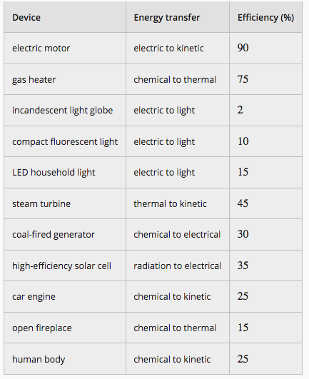

- All forms of energy eventually end up as low grade thermal energy which will be of little use.
- This total loss of useful energy is known as Heat Death.
- This is one of the ways in which our universe could die although it is unlikely that mankind will be around to witness this death.

- A more immediate and serious consequence of the Second Law of Thermodynamics is a realization that there is only a limited reserve of concentrated energy forms available (high grade) which we are degrading to less concentrated energy at a rate that cannot be sustained indefinitely.
- We shall have to find ways of conserving our concentrated sources of energy to ensure that they last as long as possible, and eventually we need to replace their use altogether.
- Most measures to conserve energy resources will go some way towards alleviating the problem of air and thermal pollution, and the atmospheric Greenhouse Effect.
- These issues pose enormous challenges to our global society as we move into the 21st century, and finding solutions requires personal, social, political and economic decisions.
- Understanding the physics involved in each of these issues is an essential part of such decision making.

PP 2.1 p 30
WSG 1.4 p19-24 Q’s 36-40 p28
Questions Answers p 29

Written type questions:
- Explain the difference between heat, temperature and internal energy.
- It is 4.00 am on a very cold winter morning. You are woken up by your cat climbing on the bed and curling up next to you. You reach out and touch the cat and find that she is very fluffy. Explain, using physics principles, how having a fluffy coat keeps the cat warm.
- Dogs don’t have sweat glands so they pant. In panting, they have a very wet tongue which they expose to the outside air. Explain how this might cool them down.
- Why is water the best liquid to use in a cooling system such as a radiator of a car?
- Why do spray cans feel cold after they have been used?
- Explain why your feet feel much colder when you walk on slate tiles in a house than when you walk on a carpet. The temperature in the house is the same all over.

Short answer type questions:
- A weather balloon has a volume of 50 L at a temperature of 20⁰C when it is on the ground (atmospheric pressure is 1.0 atm). When released into the air it rises to where the temperature is –4⁰C and the atmospheric pressure is 0.4 atm. What is the new volume of the balloon?
- A 100 g lump of copper (c = 390 J kg⁻¹ K⁻¹) has 6.0 x 10³ J of energy added to it. If it was initially at 20⁰C, what is its final temperature?
- An emersion heater heats 2.5 L of water which was initially at 15⁰C. If it takes 3.5 minutes to bring the water to boiling point (100⁰C), at what rate (in joules per second) is the water gaining heat energy?
- 0.5 kg of water at 20⁰C is all boiled away to steam at 100⁰C. How much heat energy is required?
- How much ice at 0⁰C must be added to 250 mL coffee in an insulated cup (assume no loss of heat to the container) to cool the coffee from 95⁰C to 65⁰C (use c = 4.18 x 10³ J kg⁻¹ K⁻¹ for coffee)?
- In a factory, a machine you are using applies a force of 8000 N to push a 30 kg lump of steel (c = 445 J kg⁻¹ K⁻¹) 10 m across the factory floor. If the stainless steel was initially at 20⁰C, what is its new temperature after you have pushed it across the floor?

Problem Solving type questions:

- How much heat energy is needed to change 1.0 kg ice at –5⁰C to steam at 100⁰C?
- An insulated calorimeter of mass 41 g has 100 mL of water at 15⁰C placed in it. 50 g of iron is heated to 160⁰C then carefully lowered into the water. What would be the final temperature of the water? (c_{iron} = 477 J kg⁻¹ K⁻¹, c_{copper} = 385 J kg⁻¹ K⁻¹).
- A block of an unknown alloy, mass 6 kg, at 25⁰C, is placed in an insulated copper calorimeter, mass 10 kg, containing 2 kg of water at 15⁰C. If the resulting temperature is 18⁰C, what is the specific heat of the unknown alloy?
- An insulated aluminium calorimeter with a mass of 154 g, contains 90 mL of water at a temperature of 80⁰C. 10 g of ice at -20⁰C is added to the water and the mixture stirred until the ice has dissolved. What is the final temperature of the water? (specific heat aluminium = 880 Jkg⁻¹K⁻¹)

Questions p 24-25
- Explain the difference between a conductor and an insulator.
Conductor readily allows the transfer of heat
Insulator prevents the transfer of heat
- In what phase or phases of matter does conduction occur? solids
- Explain what conduction is. Movement of heat energy through solid objects
- How does conduction occur? Include a diagram.
External source of heat energy applied to solid
Particles of solid in fixed position but are vibrating
Increasing heat energy means particles vibrate faster and hit neighbouring particles harder.
These in turn hit their neighbouring particles harder, so heat travels down solid.
Increase in kinetic energy means increase in temperature
- Some materials are good conductors and some poor. Explain what a material needs to be a good conductor. Atoms of object able to readily increase vibrations to transfer kinetic energy along the object. Free electrons also assist conduction
- What materials are good conductors? Mainly metals
- Explain why if you stand with one foot on a carpet and one on a concrete floor, your feet feel as if they are at different temperatures. Does this mean that the two materials were at different temperatures?
  - Concrete better conductor than carpet.
  - Heat energy can transfer through concrete so energy lost from your feet and thermal equilibrium reached at lower temperature so feet feel cold
  - Carpet poor conductor, prevents energy transfer through material so thermal equilibrium reached quickly and feet feel warmer
- What is convection?
Mass movement of fluids (gas and liquids) from one place to another
- In what phase or phases of matter does convection occur? Gases and liquids
- Explain how convection occurs including a diagram.
- Fluid is heated, energy added to particles increasing vibrations
- Increased vibration of particles means greater distance apart so become less dense
- Less dense fluid rises up and are replaced by cooler more dense fluid
- As moves away from heat energy, vibrations reduced and fluid becomes more dense
- Fluid sinks back down to be heated again
- This can create convection currents
- What is radiation? Energy transfer through electromagnetic waves
- Explain how radiation occurs including a diagram.
- Electromagnetic wave from sun or other hot objects is transferred without a medium
- When electromagnetic wave hits an object, the energy of the wave causes the particles to increase vibration
- Increase in vibration means increase in temperature
- Good insulating materials such as carpet, polystyrene and foam all contain trapped air. What are the advantages of this feature?
- Air is a good insulator
- Trapped air restrict the transfer of heat energy
- Material containing trapped air become insulators themselves.
- Explain why birds fluff up their feathers on a cold day and have them flat on a hot day.
- Similar to above,
- Feathers trap air
- Air is an excellent insulator and restricts the heat energy transfer from birds body to outside environment
- Summarize how a thermos flask minimizes all forms of heat transfer.
- Conduction – material thermos made of are not good conductors
- Convection - Inner and outer layers have a partial vacuum between so few molecules to help in convection
- Radiation – inside bottle coated with silver which reflects outside and inside heat preventing heat transfer by radiation.
Questions p 27
NOTE: Some of the values for specific heat and latent heat may be different from Exploring Physics

- Explain the difference between heat, temperature and internal energy.
Heat — flow of energy from a hotter to a cooler body.
Temperature — measure of the average kinetic energy of a body
Internal energy — potential and kinetic energy a body contains.

- It is 4.00 am on a very cold winter morning. You are woken up by your cat climbing on the bed and curling up next to you. You reach out and touch the cat and find that she is very fluffy. Explain, using physics principles, how having a fluffy coat keeps the cat warm.
The raised hair traps air within it. Air is a good insulator and helps prevent the flow of heat from the cat’s body to the cooler temperature of the room.

- Dogs don’t have sweat glands so they pant. In panting, they have a very wet tongue which they expose to the outside air. Explain how this might cool them down.
This is evaporation:
a. tongue has moisture on it.
b. Moisture evaporates into the air
c. In evaporating, there is a change in phase as liquid goes to gas.
d. Change of phase need energy and this energy is taken from the tongue.
e. Cooler tongue cools the blood vessels in the tongue which in turn cool the body of the dog

- Why is water the best liquid to use in a cooling system such as a radiator of a car?
Water has a very high specific heat which means that it takes a lot of energy to change the temperature of water by one degree Celsius. This then means that as a liquid in a cooling system, it will take a lot more energy from the engine before it changes temperature.

- Why do spray cans feel cold after they have been used?
Two reasons for this, but the second causes the greater temperature change.
i. Spraying can causes the pressure to decrease as gas leaves container. A decrease in pressure (without a change in volume) causes a lowering of the temperature.
ii. The substance in the can exists both as a liquid and as a vapour in the can. When the aerosol is sprayed, some of the substance leaves as vapour and therefore the vapour pressure of the can is reduced. This means that some of the liquid will then turn into vapour and to do this it needs energy. The energy is taken from the liquid, the can and your hand and so the can feels cooler.

- Explain why your feet feel much colder when you walk on slate tiles in a house than when you walk on a carpet. The temperature in the house is the same all over.
All has to do with conduction. Carpet is a poor conductor and while some of the heat from your feet will go to the top of the carpet, it can’t conduct away so the heat stays around your feet and they don’t feel cold. The tiles, on the other hand, are good conductors of heat. When your feet are on the tiles, the heat goes into the tile and is conducted away from the surface. This transfer continues until the tile and your feet reach the same temperature, which is much lower than the initial temperature of your feet so your feet feel cold.

Short answer type questions:

- A weather balloon has a volume of 50 L at a temperature of 20⁰C when it is on the ground (atmospheric pressure is 1.0 atm). When released into the air it rises to where the temperature is –4⁰C and the atmospheric pressure is 0.4 atm. What is the new volume of the balloon?
P₁V₁ = P₂V₂
T₁ T₂
V₂ = P₁V₁T₂
T₁P₂
= 1 x 50 x 277 = 118.2 L
293 x 0.4
- A 100 g lump of copper (c = 390 J kg⁻¹ K⁻¹) has 6.0 x 10³ J of energy added to it. If it was initially at 20⁰C, what is its final temperature?
Q = mcΔT
6 x 10³ = 0.1 x 390 x (T_{f} – 20)
6 x 10³ = 39 x (T_{f} – 20)
153.85 = T_{f} – 20
T_{f} = 174⁰C
- An emersion heater heats 2.5 L of water which was initially at 15⁰C. If it takes 3.5 minutes to bring the water to boiling point (100⁰C), at what rate (in joules per second) is the water gaining heat energy?
Q = mcΔT per second =
= 2.5 x 4180 x 85 = 4.23 x 10³ Js⁻¹
= 888250 J per 3.5 minutes
- 0.5 kg of water at 20⁰C is all boiled away to steam at 100⁰C. How much heat energy is required?

Q = heat water + boil water
Q = (0.5 x 4180 x 80) + (0.5 x 2.26 x 10⁶)
Q = 167200 + 1130000
Q = 1297200
Q = 1.3 x 10⁶ J
- How much ice at 0⁰C must be added to 250 mL coffee in an insulated cup (assume no loss of heat to the container) to cool the coffee from 95⁰C to 65⁰C (use c = 4.18 x 10³ J kg⁻¹ K⁻¹ for coffee)?

Heat lost = heat gained
(0.25 x 4180 x [95 – 65]) = (m x 3.34 x 10⁵) x (m x 4180 x 65)
31350 = 3.34 x 10⁵m + 271700m
31350 = 605700m
m = 5.18 x 10⁻² kg
- In a factory, a machine you are using applies a force of 8000 N to push a 30 kg lump of steel (c = 445 J kg⁻¹ K⁻¹) 10 m across the factory floor. If the stainless steel was initially at 20⁰C, what is its new temperature after you have pushed it across the floor?

W = Fs now work is energy so Q = mcΔT
= 8000 x 10 80000 = 30 x 445 x (T₂ – 20)
= 80000 J 80000 = 13350 (T₂ – 20
  - = T₂ – 20
T₂ = 25.992
T₂ = 26⁰ C
Problem Solving type questions:

- How much heat energy is needed to change 1.0 kg ice at –5⁰C to steam at 100⁰C?

Q = heat ice + melt ice + heat water + boil water
Q = (1 x 2100 x 5) + (1 x 3.34 x 10⁵) + (1 x 4180 x 100) + (1 x 2.26 x 10⁶)
Q = 10500 + 334000 + 418000 + 2260000
Q = 3022500
Q = 3.02 x 10⁶ J
- An insulated calorimeter of mass 41 g has 100 mL of water at 15⁰C placed in it. 50 g of iron is heated to 160⁰C then carefully lowered into the water. What would be the final temperature of the water? (c_{iron} = 477 J kg⁻¹ K⁻¹, c_{copper} = 385 J kg⁻¹ K⁻¹).

Heat lost = heat gained
50g iron = 41g copper + 100g water
ΔT = (160 – T_{f}) ΔT = T_{f} – 15

0.05 x 440 x (160 – T_{f}) = (0.041 x 390 x (T_{f} – 15)) + (0.1 x 4180 x (T_{f} – 15))
3520 - 22T_{f} = 15.99T_{f} - 239.85 + 418T_{f} - 6279
3520 + 239.85 + 6279 = 15.99T_{f} + 22T_{f} + 418T_{f}
10038.85 = 455.99T_{f}
T_{f} = 22⁰C

- A block of an unknown alloy, mass 6 kg, at 25⁰C, is placed in an insulated copper calorimeter, mass 10 kg, containing 2 kg of water at 15⁰C. If the resulting temperature is 18⁰C, what is the specific heat of the unknown alloy?

Heat lost = heat gained
6kg alloy = 10kg copper + 2kg water
ΔT = 7 ΔT = 3

6 x c x 7 = (10 x 390 x 3) + (2 x 4180 x 3)
42c = 11700 + 25080
42c = 36780
c = 876 J kg⁻¹ K⁻¹

- An insulated aluminium calorimeter with a mass of 154 g, contains 90 mL of water at a temperature of 80⁰C. 10 g of ice at -20⁰C is added to the water and the mixture stirred until the ice has dissolved. What is the final temperature of the water? (specific heat aluminium = 880 Jkg⁻¹K⁻¹)

Heat lost = heat gained
(0.154 x 900 x (80 – T_{f})( + (0.09 x 4180 x (80 - T_{f})) = (0.01 x 2100 x 20) + (0.01 x 334000)
+ (0.01 x 4180 x T_{f})
11088 - 138.6 T_{f} + 30096 – 376.2 T_{f} = 420 + 3340 + 41.8T_{f}
11088 + 30096 - 420 - 3340 = 138.6 T_{f} + 376 T_{f} + 41.8T_{f}
37424 = 556.4 T_{f}
T_{f} = 67⁰ C

- Summing it all up:
Heat – Transfer of energy from hotter to cooler object because of a difference in temperature.
Temperature – measure of average kinetic energy of the particles of the object.
Thermal energy (internal energy) – sum of potential and kinetic energy of object.
- Temperature Scales
- Heat is a transfer of energy so is measured in JOULES symbol J . Temperature, on the other hand, is measured using a THERMOMETER which is commonly in units called DEGREES CELSIUS.
- One degree Celsius is equal to one KELVIN degree however the zero point on the Kelvin scale is at ABSOLUTE zero or 0 K, this corresponds to -273 °C on a Celsius thermometer. Accurate thermometers are very expensive so the most commonly used one today is the liquid-in-glass type which has its fixed points as the FREEZING AND BOILING points of water e.g for a Celsius thermometer – 0 °C and 100 °C . The section in between is then divided into 100 equal divisions.
3. To convert Celsius to Kelvin, we simply add 273 K = °C + 273
To convert Kelvin to Celsius, we simply subtract 273 °C = K - 273.
4. Do the following:
- Convert these temperatures to Kelvin
- 25°C 298 K c. 46°C 319 K
- – 200°C 73 K d. 98°C 371 K
- Convert these temperatures to Celsius degrees
- 4 K -269⁰ C c. 50 K -223⁰ C
- 200 K -73⁰ C d. 430 K 157⁰ C
5. Explain what this graph is showing.
Energy of particles in a substance is normally distributed.
Temperature is the average E_{k} of particles.
Higher temperature = higher average E_{k}.

- A 400 kg block of iron is heated from 22°C to 52°C . How much heat is absorbed by the iron? (Specific heat of iron is 450 Jkg⁻¹K⁻¹)
Q = mcΔT
= 400 x 450 x (52 – 22)
Q = 5.4 x 10⁶ J
- 25.0 g of water at 90.0°C has 3657.5J of heat energy removed from it. What is its final temperature? (Specific heat of water is 4.18 x 10³ Jkg⁻¹K⁻¹)
Q = mcΔT
3657.5 = 0.025 x 4180 (90 – T_{f})
3657.5 = 104.5 (90 – T_{f})
T_{f} = 90 – 35
T_{f} = 55.0⁰C
- 50.0 g glass (specific heat of 670 Jkg⁻¹K⁻¹) at a temperature of 20°C has 4.0 x 10³ J of heat energy added. What is the final temperature of the glass?
Q = mcΔT
4000 = 0.050 x 670 x (T_{f} – 20)
4000 = 33.5 (T_{f} – 20)
119.4 = T_{f} – 20
T_{f} = 119.4 + 20 = 139.4
T_{f} = 140⁰ C
- 43.0 g of Aluminium (c = 8.80 x 10² Jkg⁻¹K⁻¹) at 90.0°C is allowed to cool to room temperature (25.0⁰C), how much heat did the aluminium give off in the cooling process?
Q = mcΔT
= 0.043 x 880 x (90 – 25)
= 2.46 x 10³ J
- 2.145 x 10³ J of heat is gained a mass of copper (c = 3.90 x 10² Jkg⁻¹K⁻¹) when it is heated from 63.0°C to 85.0°C . What was the mass of the copper?
Q = mcΔT
2145 = m x 390 x (85 – 63)
2145 = m x 390 x 22
2145 = 8580m
m = 0.250 kg
- 3.50 x 10³ J of heat is added to 1.80 kg of lead (c = 1.30 x 10² Jkg⁻¹K⁻¹) which was initially at 10.0°C . What is the final temperature of the lead?
Q = mcΔT
3500 = 1.80 x 130 x (T_{f} – 10)
3500 = 234 (T_{f} – 10)
14.96 = T_{f} – 10
T_{f} = 25.0⁰ C
- 855 g of aluminium (c = 8.80 x 10² Jkg⁻¹K⁻¹) initially at 68.0°C was cooled by removing 2.69 x 10⁴ J of heat energy. What was the final temperature of the aluminium?
Q = mcΔT
26 900 = 0.855 x 880 x (68 – T_{f})
26 900 = 752.4 x (68 – T_{f})
35.75 = 68 – T_{f}
T_{f} = 32.2⁰ C
- An aluminium saucepan of mass 855 g has 0.200 kg of milk (specific heat 3.90 x 10³ J) in it which has been heated to a temperature of 90.0°C . How much heat energy must be removed for them both to reach a temperature of 45.0°C ?
Q = m_{A}c_{A}ΔT_{A} + m_{M}c_{M}ΔT_{M}
= 0.855 x 880 x (90 – 45) + 0.200 x 3900 x (90 – 45)
= 33858 + 35100
= 68958
Q = 6.90 x 10⁴ J

- Change from solid to liquid is called Latent Heat of Fusion L_{f}
- Change from liquid to gas is called Latent Heat of Vaporisation L_{v}
- Note that the Latent Heat of Fusion is less than the Latent Heat of Vaporization. This is always the case. Can you suggest why this is so?
Particles in a solid and liquid are much closer together than particles in a gas. The amount of energy needed to move particles apart from solid to liquid is therefore much less than moving particles apart in gases.
- How much heat is required to evaporate 5.0 kg of benzene at its boiling point? The Latent Heat of Vaporization of benzene is 4.0 x 10⁴ Jkg⁻¹.

Q = mL
= 5.0 x 4.0 x 10⁴
Q = 2.0 x 10⁵ J
50 g of ice at –10°C is heated to steam at 120°C .
Heat Energy = heat ice + ice to water + heat water + water to steam + heat steam
= mcΔT_{(ice)} + mL_{f} + mcΔT_{(water)} + mL_{v} + mcΔT_{(steam)}

Q = (0.05 x 2.0 x 10)+(0.05x3.34 x 10⁵)+(0.05 x 4180 x 100)+(0.05x2.25 x 10⁶)+(0.05x 2000x 20)
Q = 1.53 x 10⁵ J
Points to note:
- Different phases have different “c” vales
- Temperature change always positive
- Each phase has temperature change for that phase so ΔT not 130°C but appropriate value for phase substance is in
- 0.1 kg of an unknown metal is found to require 3.5 kJ to change its temperature from 25°C to 82°C . What is the specific heat of the metal?
Q = mcΔT
3500 = 0.1 x c x 57
c = 6.1 x 10² J kg⁻¹ K⁻¹
- The specific heat of copper is 3.85 x 10² J kg⁻¹ K⁻¹. A specific mass of copper has 1.74 x 10⁴ J of energy added to it to change its temperature from 20°C to 80°C. What was the mass of copper?
Q = mcΔT
1.74 x 10⁴ = m x 385 x 60
m = 0.75 kg
- If 15.7 kJ of heat energy is added to 250 mL of water at 20°C, what is the new temperature?
Q = mcΔT
15.7 x 10³ = 0.25 x 4180 x (T_{f} – 20)
T_{f} – 20 =
T_{f} – 20 = 15.024
T_{f} = 35⁰ C
- Over a period of 6 hours, a hot water bottle cools from 95°C to 20°C. If the hot water bottle held 2.5 L water, what is the rate of cooling in Js⁻¹?
Q = 2.5 x 4180 x 75
= 783750 J
Energy per second =
= 36 Js⁻¹
- A kettle rated at 2000 W contains 1.8 L water at 15°C. If it runs for 3.5 minutes, will the water boil?
Q = mcΔT
Q = P x t 420000 = 1.8 x 4180 x (T_{f} – 15)
= 2000 x (3.5 x 60) T_{f} – 15 =
= 420000 J T_{f} – 15 = 55.82
T_{f} = 55.82 + 15
T_{f} = 71⁰C
So water will not boil.
- How much heat energy is released when 423 g of steam at 100°C condenses to water also at 100°C?
Q = mL
= 0.423 x 2.26 x 10⁶
Q = 9.6 x 10⁵ J
- 4.87 x 10⁵ J of heat are added to a mass of ice at 0°C. If the ice melts and becomes water at 21.5°C , what was the mass of ice?
Q = melt ice + heat water
Q = mL + mcΔT
4.87 x 10⁵ = (m x 3.34 x 10⁵) + (m x 4180 x 21.5)
4.87 x 10⁵ = 3.34 x 10⁵m + 89870m
4.87 x 10⁵ = 423870 m
m = 1.15 kg ice

- At what rate in Js⁻¹ is a refrigerator absorbing heat from 2.15 kg of water at 21.5°C is just frozen in 2.00 hours?

Q = (cool water) + (freeze water)
= (mcΔT) + (mL_{f})
= (2.15 x 4180 x 21.5) + (2.15 x 3.34 x 10⁵)
= 193220.5 + 718100
= 911320.5 J per 2 hours

rate in J s⁻¹ =
= 126.57
= 127 J s⁻¹
- Heat Problems
- 20 g of milk at 5.00°C is added to 250 g of coffee at 90.0°C. What is the final temperature of the drink?
Heat lost = Heat gained
mcΔT coffee = mcΔT milk
0.25 x 4100 x (90 – T_{f}) = 0.02 x 3900 x (T_{f} – 5)
1025 x (90 – T_{f}) = 78 x (T_{f} – 5)
92250 – 1025T_{f} = 78T_{f} – 390
92250 + 390 = 78T_{f} + 1025T_{f}
92640 = 1103T_{f}
T_{f} =
T_{f} = 84.0°C
- 100 g of a metal at 95.0°C is added to 5.00 x 10² mL of water at 2.00°C. If the final temperature of the water is 3.60°C, what is the specific heat of the metal?
Heat lost = Heat gained
(mcΔT) metal = (mcΔT) water
0.1 x c x (95 – 3.6) = 0.5 x 4180 x (3.6 -2)
9.14c = 3344
c =

c = 366 J kg⁻¹ K⁻¹
- How much heat energy is needed to change 1.00 kg of ice at –3.00°C to steam at 107°C?
Q = heat ice + melt ice + heat water + boil water + heat steam
= (mcΔT)_{ice} + (mL_{f}) + (mcΔT)_{water} + (mL_{v}) + (mcΔT)_{steam}
= (1.0 x 2100 x 3) + (1.0 x 3.34 x 10⁵) + (1.0 x 4180 x 100) + (1.0 x 2.26 x 10⁶)
+ (1.0 x 2000 x 7)
= 6300 + 3.34 x 10⁵ + 418000 + 2.26 x 10⁶ + 14000
= 3.03 x 10⁶
Q = 3.03 x 10⁶ J
- How much ice at 0.0°C must be added to 250 mL of coffee (specific heat: 4.10 x 10³ Jkg⁻¹K⁻¹) in an insulated cup (assume no loss of heat to the container and surroundings) to cool the coffee from 95°C to 65°C?
Heat lost = Heat gained
coffee at 95°C = ice at 0°C
cool coffee = melt ice + heat ice/water
(mcΔT) _{coffee} = mL + mcΔT
0.25 x 4100 x (95 – 65) = (m x 3.34 x 10⁵) + (m x 4180 x 65)
30750 = 3.34 x 10⁵m + 271700m
30750 = 605700m
m = 0.05077
m = 5.08 x 10⁻² kg
- Copper calorimeters are used to determine the specific heat of unknown substances. A calorimeter of mass 41 g, has 100 mL of water at 15°C placed in it. 50 g of iron is heated to 160°C then carefully lowered into the water. What would be the final temperature of the water? (specific heat of copper is 385 Jkg⁻¹K⁻¹ , iron is 477 Jkg⁻¹K⁻¹)
Heat lost = Heat gained
cool iron = heat water + heat calorimeter (so no phase change)
(mcΔT)_{iron} = (mcΔT)_{water} + (mcΔT)_{copper}
0.05 x 477 x (160 – T_{f}) = (0.10 x 4180 x [T_{f} – 15]) + (0.041 x 385 x [T_{f} – 15])
3816 – 23.85T_{f} = 418T_{f} - 6270 + 15.785T_{f} - 236.775
316 + 6270 + 236.775 = 23.85T_{f} + 15.785T_{f} + 418T_{f}
10322.775 = 457.635T_{f}
T_{f} = 22.6°C
- 5.00 g of ice at –2.00°C is placed into a 78.0 g copper calorimeter containing 120 mL of water at 90.0°C. The water is stirred until all the ice has dissolved. What is the final temperature of the water?
Heat lost = Heat gained
cool water + cool calorimeter = heat ice + melt ice + heat ice/water
(mcΔT)_{water} + (mcΔT)_{calorimeter} = (mcΔT)_{ice} + (mL_{f}) + (mcΔT)_{ice/water}
(0.12 x 4180 x (90 – T_{f})) + (0.078 x 385 x (90 – T_{f})) =
(0.005 x 2100 x (90 – T_{f}) + (0.005 x 3.34 x 10⁵) + (0.005 x 4180 x T_{f})
45144 – 501.6T_{f} + 2702.7 – 30.03T_{f} = 21 + 1670 + 20.9T_{f}
-501.6T_{f} – 30.03T_{f} – 20.9T_{f} = -45144 – 2702.7 + 21 +1670
-552.53T_{f} = -45603.17
552.53T_{f} = 45603.17
T_{f} = 83.5°C
- A 5.45 kg steel container contains 12.0 kg of water at 22.0°C. When 2.65 kg of molten alloy (latent heat of fusion 2.50 x 10⁴ J kg⁻¹ K⁻¹) at its melting point of 327°C is poured into the water the final temperature reached is 27.8°C. Find the specific heat of the alloy.
Heat lost = Heat gained
(solidify alloy) + (cool alloy) = (heat container) + (heat water)
(mL_{f}) + (mcΔT)_{alloy} = (mcΔT)_{steel} + (mcΔT)_{water}
(2.65 x 25000) + (2.65 x c x 2992) = (5.45 x 450 x 5.8) + (12 x 4180 x 5.8)
66250 + 792.88c = 14224.5 + 290928
792.88c = 14224.5 + 290928 - 66250
792.88c = 238902.5
c = 301 J kg⁻¹ K⁻¹
- How much ice at -4.00°C must be added to an aluminium calorimeter of mass 47.0 g containing 150 g of water at 95.0°C so that the final temperature once the ice has fully melted is 70°C?
Heat lost = Heat gained
cool water + cool aluminium = heat ice + melt ice + heat ice/water
(0.047 x 880 x 25) + (0.15 x 4180 x 25) = (m x 2100 x 4) + (m x 4180 x 70) + m x 3.34 x 10⁵)
1034 + 15675 = 8400m + 292600m + 3.34 x 10⁵
16709 = 635000m
m = 0.0263 kg

